Development of IoT Based Smart Healthcare Monitoring System

## Abstract:

With the advancement of technology, further developing towards the Internet of Things and miniaturization of sensors, the endeavours to attain a quality lifestyle is something to be still sought for. With the applications of technology being used in diverse industries, one such industry witnessing this technological disrupt is the Healthcare sector.

In this project, we have made an effort to engineer an affordable, remote, yet accurate IoT Health Monitoring system using sensors, modules, cloud IOT platform. This can help to limit the spread of disease and get a proper diagnosis of the patient's health, even under circumstances where the doctor is at a far distance. Health data is uploaded in real-time and can be tracked and diagnosed by the authorized person through a Things Speak IoT platform without the requirement of the patient visiting the doctor. Feedbacks based on the analyzed data can be sent back to the doctor or guardian through Email and/or SMS alerts in case of any emergencies.

**Keywords:**

*Smart Healthcare Monitoring System, Internet of Things, IoT based Health Monitoring, temperature sensor, pulse sensor.*

## Introduction:

As per WHO, Health is characterized as a full state of physical, mental, and social well-being and not merely a lack of illness. Health has always a considerable solicitude in every field the human race has advanced when it comes to technology. For example, the recent

life-threatening COVID-19 disrupting the worldwide economy is an instance of how health care needs detailed research and attention. In such conditions where the pandemic hits, it is always suggested to monitor patients using remote health monitoring technology.

The past few years have been a stepping stone for wireless technology to uphold the needs of various sectors. IoT has grabbed the automation and control area of industrial space especially. Similarly, innumerable everyday users are being benefited from M-Health (Mobile Health) applications and E-Health (health care supported by ICT) to bring innovation for maintaining their health.

Also for aged patients from remote regions, devoid of hospitals, visiting hospitals in urban sites becomes laborious owing to travelling and cost issues. Such health-related issues can be limited with the implementation of IoT based sophisticated patient health monitoring. Remote

Patient Monitoring arrangement empowers observation of patients outside of customary clinical settings (e.g. at home), which expands access to human services offices to bring down expenses. This will additionally reduce the time spent on getting registered for appointments, generating check-up reports, and other logistics, preventing complication and personal costs.

# DETAILED DESCRIPTION OF THE COMPONENTS

## TEMPERATURE SENSOR:-

**MLX-90614**

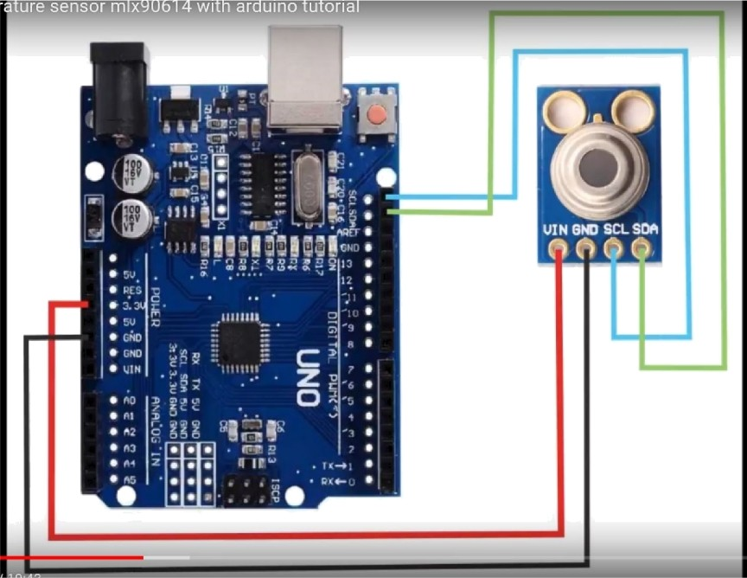

MLX9O614 Pinout Configuration

|  |  |  |
| --- | --- | --- |
| Pin No. | Pin Name | Description |
| 1 | Vdd (Power supply) | Vdd can be used to power the sensor, typically using 5V |
| 2 | Ground  SDA — Serial Data | The metal can also act as ground  Serial data pin used for T2C Communication |
| 4 | SCL — Serial Clock | Serial Clock Pin used for I2C Communication |

**MLX9O634 Temperature Sensor Specifications**

* Operating Voltage: 3.6V to 5V (available in 3V and 5V version)
* Supply Current: 1.5mA
* Object Temperature Range: -70° C to 382.2°C
* Ambient Temperature Range: -40° C to 125°C
* Accuracy: 0.02°C
* Field of View: 80°
* Distance between object and sensor: 2cm-5cm (approx.)

### Working Principle of MLX9O614

As mentioned earlier, the MLX90614 sensor can measure the temperature of an object without any physical contact with it. This is made possible with a law called **Stefan-Boltzmann Law,** which states that all objects and living beings emit IR Energy and the intensity of this emitted IR energy will be directly proportional to the temperature of that object or living being. So the MLX906 1 4 sensor calculates the temperature of an object by measuring the amount of IR energy emitted from it.

### How to use MLX9O614 Thermometer Sensor

The MLX906 14 Temperature sensor is manufactured by a company called Melexis. The sensor is factory calibrated and hence it acts like a plug and play sensor module for speeding up development processes.

The MLX90614 consists of two devices embedded as a single sensor, one device acts as a sensing unit and the other device acts as a processing unit. The sensing unit an **Infrared Thermopile Detector** called MLXB1 101 which senses the temperature and the processing unit is **a Single Conditioning ASSP** called MLX903O2 which converts the signal from the sensor to digital value and communicates using I2C protocol. The MLX90302 has a low noise amplifier, 17-bit ADC and a powerful DSP which helps the sensor to have high accuracy and resolution.

The sensor requires no external components and can be directly interfaced with a microcontroller like Arduino. As you can see above the power pins (Vdd and Gnd) can be directly used to power the sensor, typically 5V can be used, but there are other versions of this sensor which can operate an 3.3V and 7V as well. The capacitor C1 is optional and is used to filter noise and provide optimum EMC. The signal pins (SCL and SDA) for used for I2C communication and can be connected directly to microcontroller operating on 5V logic.

The sensor is also sold as a module as you can see in the pinout image. But the sensor module is very similar to the sensor itself and does not have any additional components other than the sensor itself.

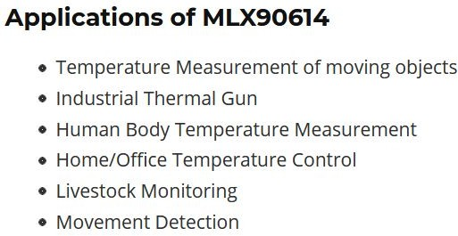

[**https://youtu.be/NzMncrfZAmU**](https://youtu.be/NzMncrfZAmU)

**Code:-**

**#include <LiquidCrystal_I2C.h> #include <Wire.h>**

**#include <Adafruit_MLX90614.h>**

**#define I2C_ADDR 0x27 //I2C adress, you should use the code to scan the adress first (0x27) here**

**#define BACKLIGHT_PIN 3 // Declaring LCD Pins #define En_pin 2**

**#define Rw_pin 1 #define Rs_pin 0 #define D4_pin 4 #define D5_pin 5 #define D6_pin 6 #define D7_pin 7**

**LiquidCrystal_I2C lcd(I2C_ADDR,En_pin,Rw_pin,Rs_pin,D4_pin,D5_pin,D6_pin,D7_ pin);**

**Adafruit_MLX90614 mlx = Adafruit_MLX90614();**

**void setup() {**

**mlx.begin();**

**lcd.begin (16,2);**

**lcd.setBacklightPin(BACKLIGHT_PIN,POSITIVE);**

**lcd.setBacklight(HIGH); //Lighting backlight**

**lcd.home ();**

**}**

**PULSE RATE SENSOR:-**

**MAX30102:-**

**Benefits and Features**

* Heart-Rate Monitor and Pulse Oximeter Sensor in LED Reflective Solution
* Tiny 5.6mm x 3.3mm x 1.55mm 14-Pin Optical Module
  + Integrated Cover Glass for Optimal, Robust

Performance

* Ultra-Low Power Operation for Mobile Devices
  + Programmable Sample Rate and LED Current for Power Savings
  + Low-Power Heart-Rate Monitor (< 1mW)
  + Ultra-Low Shutdown Current (0.7µA, typ)
* Fast Data Output Capability
  + High Sample Rates
* Robust Motion Artifact Resilience
  + High SNR
* -40°C to +85°C Operating Temperature Range

**Applications**

* Wearable Devices
* Fitness Assistant Devices
* Smartphones
* Tablets

**Pin description:**

**VIN**: main power supply input, 1.8V~5V

**3-bit pad:** selects the pull-up level of the bus, depending on the pin master voltage, optional 1.8V or 3.3V end (this end contains 3.3V and above)

**SCL:** the clock connected to the I2C bus

**SDA:** data connected to the I2C bus

**INT:** interrupt pin of the MAX30102 chip

**RD:** RED LED ground terminal of MAX30102 chip, generally not connected

**IRD:** the IR LED ground of the MAX30102 chip is generally not

connected

**GND:** ground wire

**Principle description:**

**Photodissolution method:**

The measurement of pulse and blood oxygen saturation is performed by using human tissue to cause different light transmittance when the blood vessel beats.

Light source:

A specific wavelength of light-emitting diode selective for oxyhemoglobin (HbO2) and hemoglobin (Hb) in arterial blood.

**Light transmittance is converted into an electrical signal:**

The change in the volume of the arterial pulsation causes the light transmittance of the light to change. At this time the light reflected by the human tissue is received by the photoelectric transducer, converted into an electrical signal, and amplified and output.

Why MAX30102 would be suitable as compared to other sensors?

* The MAX30102 integrates red and IR LEDs to modulate LED pulses for oxygen saturation (SpO2) and heart rate measurements.
* Space savings: Maintains a very small solution size without sacrificing optical or electrical performance; Integrates internal LEDs, photodetectors, optical elements, and low-noise electronics with ambient light rejection

**MAX30102 WITH ARDUINO:-**

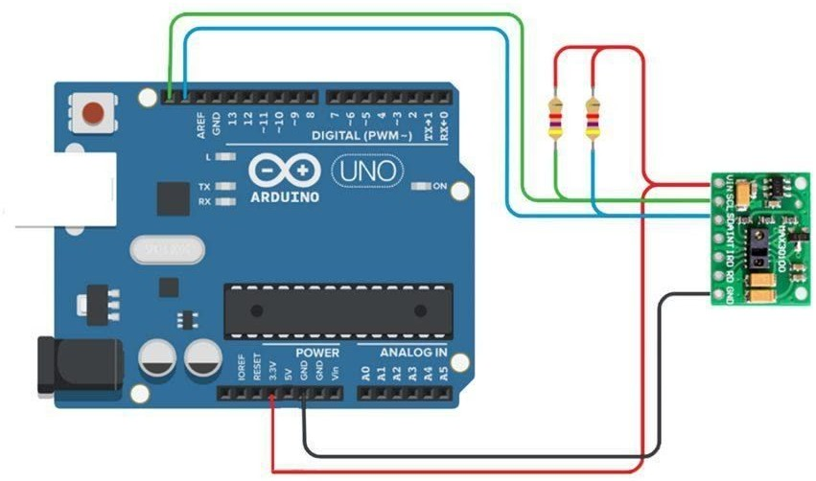

**CODE:-**

#include <Adafruit_GFX.h> //OLED libraries #include <Adafruit_SSD1306.h>

#include <Wire.h>

#include "MAX30105.h" //MAX3010x library

#include "heartRate.h" //Heart rate calculating algorithm MAX30105 particleSensor;

const byte RATE_SIZE = 4; //Increase this for more averaging. 4 is good.

byte rates[RATE_SIZE]; //Array of heart rates byte rateSpot = 0;

long lastBeat = 0; //Time at which the last beat occurred float beatsPerMinute;

int beatAvg;

#define SCREEN_WIDTH 128 // OLED display width, in pixels #define SCREEN_HEIGHT 32 // OLED display height, in pixels #define OLED_RESET -1 // Reset pin # (or -1 if sharing Arduino reset pin)

Adafruit_SSD1306 display(SCREEN_WIDTH, SCREEN_HEIGHT, &Wire, OLED_RESET); //Declaring the display name (display)

static const unsigned char PROGMEM logo2_bmp[] =

{ 0x03, 0xC0, 0xF0, 0x06, 0x71, 0x8C, 0x0C, 0x1B, 0x06, 0x18,

0x0E, 0x02, 0x10, 0x0C, 0x03, 0x10, //Logo2 and Logo3 are two bmp pictures that display on the OLED if called

0x04, 0x01, 0x10, 0x04, 0x01, 0x10, 0x40, 0x01, 0x10, 0x40,

0x01, 0x10, 0xC0, 0x03, 0x08, 0x88,

0x02, 0x08, 0xB8, 0x04, 0xFF, 0x37, 0x08, 0x01, 0x30, 0x18,

0x01, 0x90, 0x30, 0x00, 0xC0, 0x60,

0x00, 0x60, 0xC0, 0x00, 0x31, 0x80, 0x00, 0x1B, 0x00, 0x00,

0x0E, 0x00, 0x00, 0x04, 0x00, };

static const unsigned char PROGMEM logo3_bmp[] =

{ 0x01, 0xF0, 0x0F, 0x80, 0x06, 0x1C, 0x38, 0x60, 0x18, 0x06, 0x60, 0x18, 0x10, 0x01, 0x80, 0x08,

0x20, 0x01, 0x80, 0x04, 0x40, 0x00, 0x00, 0x02, 0x40, 0x00,

0x00, 0x02, 0xC0, 0x00, 0x08, 0x03,

0x80, 0x00, 0x08, 0x01, 0x80, 0x00, 0x18, 0x01, 0x80, 0x00,

0x1C, 0x01, 0x80, 0x00, 0x14, 0x00,

0x80, 0x00, 0x14, 0x00, 0x80, 0x00, 0x14, 0x00, 0x40, 0x10,

0x12, 0x00, 0x40, 0x10, 0x12, 0x00,

0x7E, 0x1F, 0x23, 0xFE, 0x03, 0x31, 0xA0, 0x04, 0x01, 0xA0,

0xA0, 0x0C, 0x00, 0xA0, 0xA0, 0x08,

0x00, 0x60, 0xE0, 0x10, 0x00, 0x20, 0x60, 0x20, 0x06, 0x00,

0x40, 0x60, 0x03, 0x00, 0x40, 0xC0,

0x01, 0x80, 0x01, 0x80, 0x00, 0xC0, 0x03, 0x00, 0x00, 0x60,

0x06, 0x00, 0x00, 0x30, 0x0C, 0x00,

0x00, 0x08, 0x10, 0x00, 0x00, 0x06, 0x60, 0x00, 0x00, 0x03,

0xC0, 0x00, 0x00, 0x01, 0x80, 0x00 };

void setup() {

display.begin(SSD1306_SWITCHCAPVCC, 0x3C); //Start the OLED display

display.display(); delay(3000);

// Initialize sensor

particleSensor.begin(Wire, I2C_SPEED_FAST); //Use default I2C port, 400kHz speed

particleSensor.setup(); //Configure sensor with default settings

particleSensor.setPulseAmplitudeRed(0x0A); //Turn Red LED to low to indicate sensor is running

}

void loop() {

long irValue = particleSensor.getIR(); //Reading the IR value it will permit us to know if there's a finger on the sensor or not

//Also detecting a heartbeat

if(irValue > 7000){ //If a finger is detected

display.clearDisplay(); //Clear the display display.drawBitmap(5, 5, logo2_bmp, 24, 21, WHITE);

//Draw the first bmp picture (little heart)

display.setTextSize(2); //Near it display the average BPM you can display the BPM if you want

display.setTextColor(WHITE); display.setCursor(50,0); display.println("BPM"); display.setCursor(50,18); display.println(beatAvg); display.display();

if (checkForBeat(irValue) == true) //If a heart beat is detected

{

display.clearDisplay(); //Clear the display display.drawBitmap(0, 0, logo3_bmp, 32, 32, WHITE); //Draw

the second picture (bigger heart)

display.setTextSize(2); //And still displays the average BPM

display.setTextColor(WHITE); display.setCursor(50,0); display.println("BPM"); display.setCursor(50,18); display.println(beatAvg); display.display();

tone(3,0); //And tone the buzzer for a 100ms you can reduce it it will be better

delay(100);

noTone(3); //Deactivate the buzzer to have the effect of a "bip"

//We sensed a beat!

long delta = millis() - lastBeat; //Measure duration between two beats

lastBeat = millis();

beatsPerMinute = 60 / (delta / 1000.0); //Calculating the BPM

if (beatsPerMinute < 255 && beatsPerMinute > 20)

//To calculate the average we strore some values (4) then do some math to calculate the average

{

rates[rateSpot++] = (byte)beatsPerMinute; //Store this reading in the array

rateSpot %= RATE_SIZE; //Wrap variable

//Take average of readings beatAvg = 0;

for (byte x = 0 ; x < RATE_SIZE ; x++)

beatAvg += rates[x]; beatAvg /= RATE_SIZE;

}

}

}

if (irValue < 7000){ //If no finger is detected it inform the user

and put the average BPM to 0 or it will be stored for the next measure

beatAvg=0; display.clearDisplay(); display.setTextSize(1); display.setTextColor(WHITE); display.setCursor(30,5); display.println("Please Place "); display.setCursor(30,15); display.println("your finger "); display.display();

noTone(3);

}

}

**WORKING AND OVERVIEW**

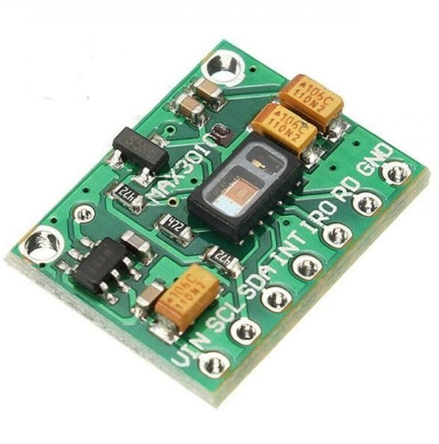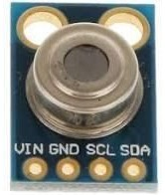 **GADGET:-**

**MLX90614 DIMENSION:-**

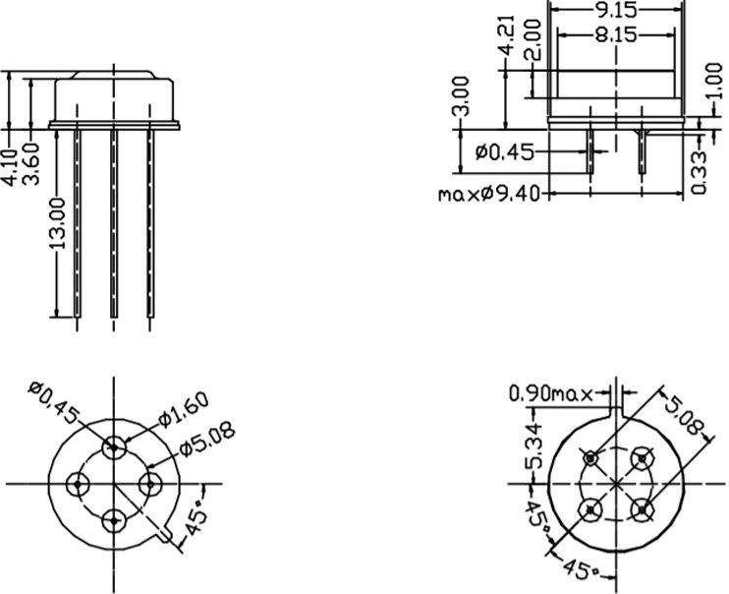

**Top View:-**

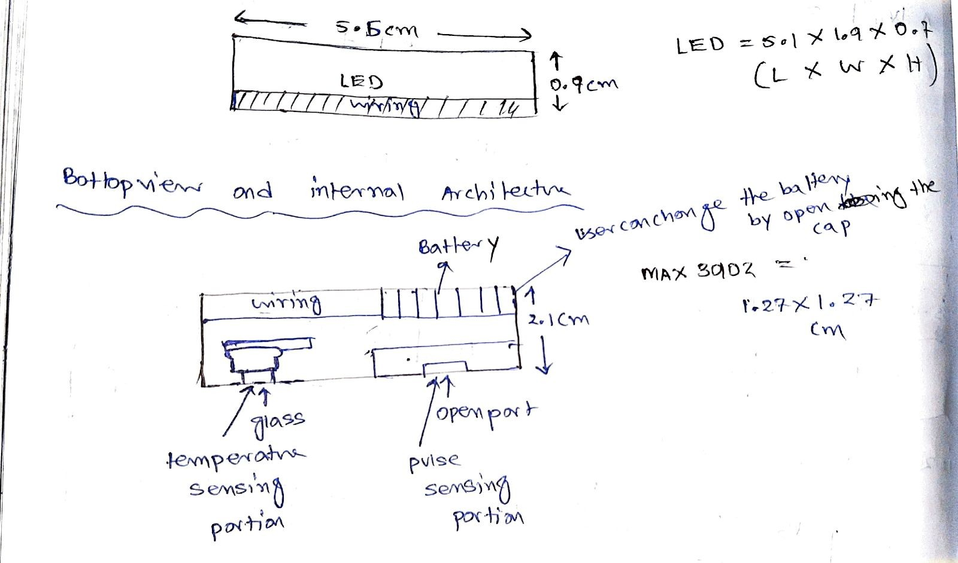

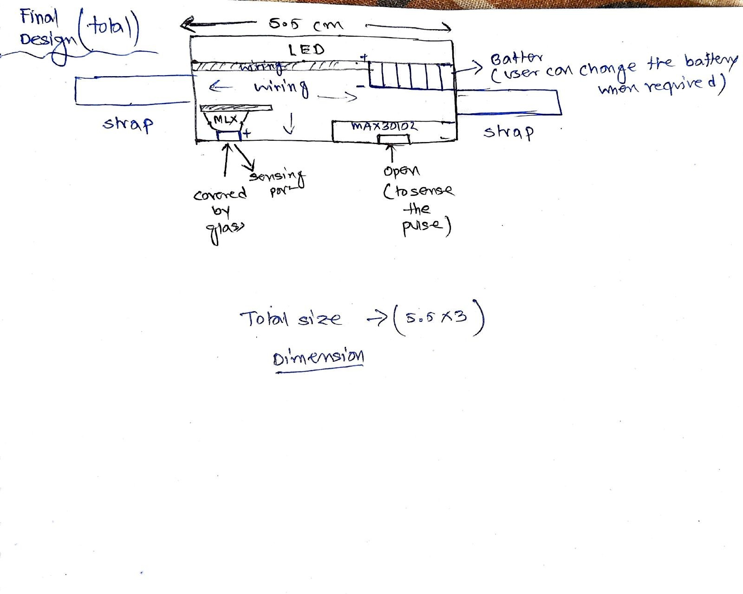

**COMPONENT:-**

1. Strap
2. Battery case 3. MLX 90614 4. MAX 30102
3. Wires
4. 4-Bit 7-Segment 0.56" Red LED Digital Display Tube For DIY or Arduino
5. Casings.
6. Panasonic CR2032 3V Lithium Coin Battery,(5 nos)

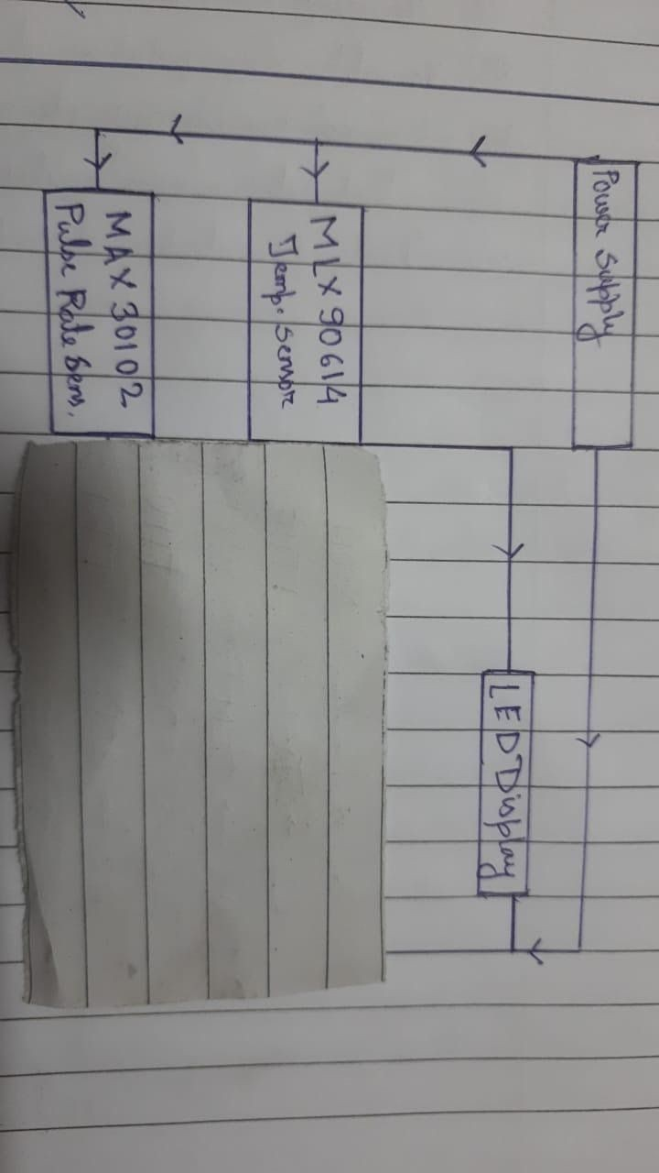

Block Diagram of the System

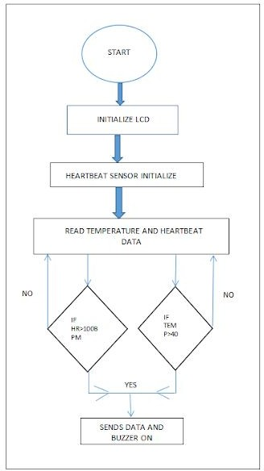

Flowchart of the System

**Literature Review**

In [1], the authors proposed the health monitoring system that monitors the heart rate in pulses and temperature of the patients along with some environmental parameters that are measured by room temperature sensor, CO sensor, and CO2 sensor. The acquired data is transmitted over wireless networks, maintained in a single database of patients, giving an alert to the authorities, aside from personalization of critical health related criteria. The verified medical team collects the raw data, analyzes, makes and makes decisions virtually using the data, without meeting in person. The advanced prototype supported by experimental result analysis, graphical interpretations and minimal error rate proves the effectiveness of the system.

Deepak et. al, [2] proposed a monitoring system using an ARM controller, bluetooth

module(HC-05), SIM800L GPRS modem and 3 sensors(temperature, pulse and MEMS). These sensors attached to the patient body determine temperature, pulse rate and fall detection.

Thereupon this data is sent to the ARM7 controller, and further the data is transmitted with the

help of Bluetooth module to Smart phone application and cloud with the help of GPRS module. Thus ARM7, apart from being the core of the entire system acted like an interface between the input(sensors) and output(modules and modem).

In [3], the authors proposed a system that effectively monitor the patient's pulse rate in real time. The sensor, connected to the Microcontroller in Arduino UNO acted as a source of the data which wa acquired by the sensor node via Microcontroller.The next step involved was data

pro-processing the data model acquired from the data acquisition and identifying them as a label. This data is sent to the cloud/database(Things Speak) for the additional scope of appropriation in data analysis and data mining. This data is taken to observe the parameters for the future observation, predictions etc. The abnormality in the pulse rate is observed with the GSM and the Buzzer.

Tamilselvi et al. [4] proposed an IoT health monitoring system to track the basic symptoms of a patient like percentage of oxygen saturation, heart rate, body temperature, and eye movement within the IoT framework and network. For the implementation purpose, the system used Heartbeat, SpO2, Temperature, and Eye blink sensors to collect data and Arduino-UNO was used as a processing device. The developed system was implemented but no specific performance measures are described for any patient.

In [5], Authors have done a comprehensive study on the recent advancements in IoT-based healthcare technologies, the IoT network architectures/platforms, applications, and industrial trends. They have also analyzed several other IoT security and privacy features,which includes threat models, security requirements, and attack taxonomies when taken from the perspective of the health care industry. Further, to face the challenges for future research on Io based healthcare, they have proposed a smart collaborative security model that considerably lessens security risk; explains how innovations like big data, Machine learning, ambient intelligence, and wearables technology that can be leveraged in a health care context.

**Conclusion**

Wireless health monitoring lessens the time taken in collecting the patient’s data, and the data collected with the help of sensing devices proves to be more accurate than the layman's system. The transmitted patient data is stored, analysed with proper analytic tool, and based on the report, the prediction of progress of diseases are done. The proposed system can be used at home and hospital. This system also does not affect the situation of patients ailing with systemic organ diseases like heart, kidney and respiratory diseases. By using IOT monitoring devices coupled with a cloud environment, the database of the patient's health history is shared to the hospital for taking into account the further treatment and intensive care. Old patients could be especially benefited by sitting in home itself, the basic tests and regular check-ups can be done and could avoid visiting the clinic frequently especially during this Covid period. This system can be further improved to monitor more than two parameters of patient health information.

**References**

[1]. Md. Milon Islam, Ashikur Rahaman and Md. Rashedul Islam. 2020. Development of Smart Healthcare Monitoring System in IOT Environment *Springer Nature Singapore Pte Ltd*.

[2]. Deepak N, Rajendra Prasad C H and Sanjay Kumar Ch. 2018. Patient Health Monitoring using IOT *International Journal of Innovative Technology and Exploring Engineering* 8.

[3]. Hari Kishore K, Surendra Nath K V, Hari Krishna K V N, Pavan Kumar D, Manikanta V and Fazal Noor Basha. 2019. IOT Based Smart Health Monitoring Alert Device *International Journal of Innovative Technology and Exploring Engineering* 8.

[4]. Tamilselvi V, Sribalaji S, Vigneshwaran P, Vinu P, GeethaRamani J. IoT based health monitoring system. In: 2020 6th International conference on advanced computing and communication systems (ICACCS). IEEE; 2020. p. 386–9

[5]. Riazul Islam SM, Kwak Daehan, Humaun Kabir M, Hossain M, Kwak Kyung-Sup. The Internet of Things for health care: a comprehensive survey. *IEEE Access. 2015;3:678–708*.

[6]. Prakash H Patil, Pratyush Singh, Swatee Biradar and Prasad Rane. 2013. Design and Implementation of Wireless Patient Health Monitoring System *International Journal of Engineering Research and Technology 2* (6).

[7]. Rahaman A, Islam M, Islam M, Sadi M, Nooruddin S. Developing IoT based smart health monitoring systems: a review. *Rev Intell Artif. 2019;33:435–440. doi: 10.18280/ria.330605.*

[8]. Islam M S, Islam M T, Ali F. Almutairi, GankokBeng, Amid N M N. 2019. Monitoring of the Human Body Signal through the Internet of Things (IoT) Based LoRa Wireless Network *System Journal of Applied Sciences 9*

[9]. Desai MR, Toravi S. A smart sensor interface for smart homes and heart beat monitoring using WSN in IoT environment. *In: 2017 International conference on current trends in computer, electrical, electronics and communication (CTCEEC). IEEE; 2017. p. 74–7*